MISSING NUMBER
KS1 – 2001 Paper
1.
5

KS1 – 2003 Paper 1
2.
KS1 – 2004 Paper 2
3.
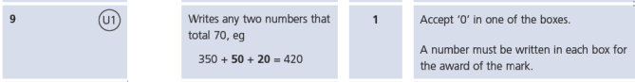
4.
KS1 – 2009 Paper 1
5.
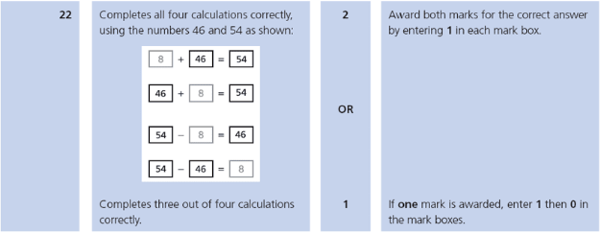
KS1 – 2016 Paper - Reasoning
6.
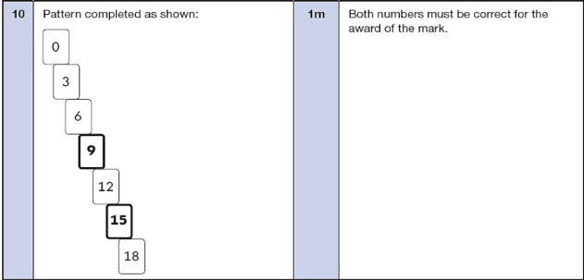
KS1 – 2017 Paper – Reasoning
7.
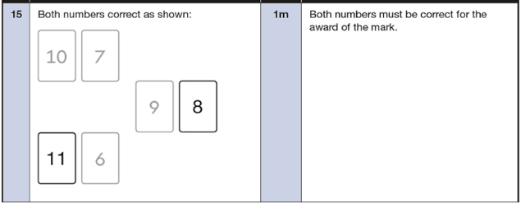
8.
KS1 – 2018 Paper – Reasoning
9.
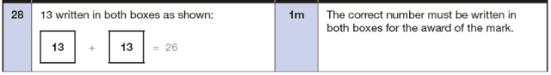
10.
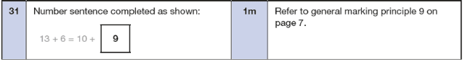
KS1 – 2019 Paper – Reasoning
11.
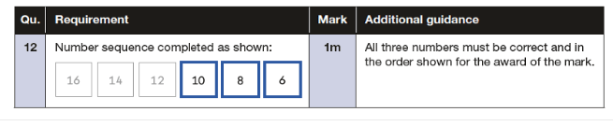
KS1 – 2022 Paper – Reasoning
12.
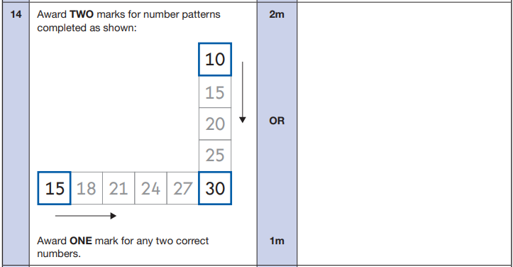

13.
